- Purpose
  - The purpose of this document is to describe the procedure for assembling the Solution Canister on the Genesys Machine.
- Scope
  - This SOP applies to all equipment assembly team members. The process applies to the following machine ID’s:
EP50329EQS0600BE1200 – Solution Delivery
EP50280EQS0600BE1200 – SoliChem Canister Assembly
- Responsibilities
  - The operations manager/supervisor is responsible for enforcing this SOP.
- Materials
  - The proper materials needed for this process are listed on the machine work order.
- Definitions

- Procedure
  - Take a bottom tube end cap (E29316) and press a T-Fitting (E29315) into the bottom.
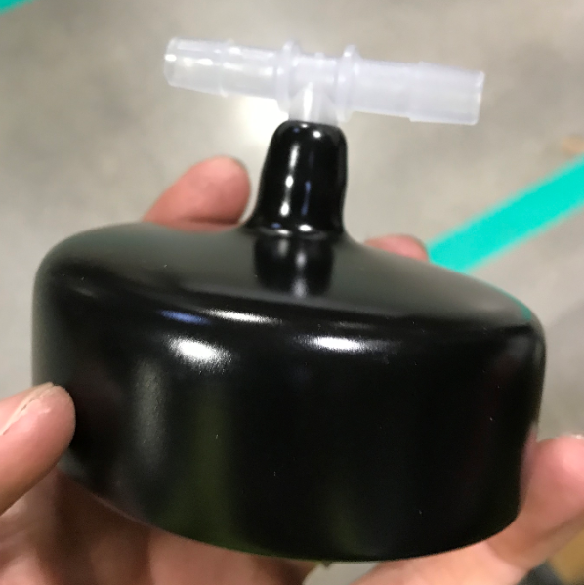
  - Install a clear chem tube (E29306) into the bottom cap.

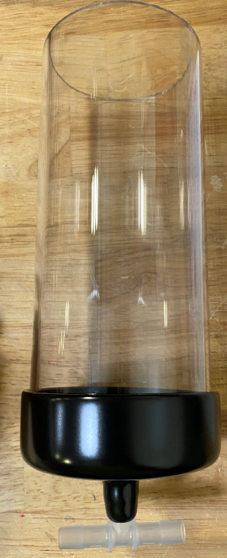
  - Take a barbed fitting (E28786) and wrap some thread tape on the threads. Thread the barbed fitting into a 90° brass fitting (E29320). Ensure the fitting is in the orientation shown.
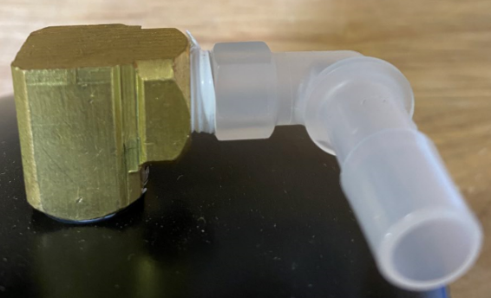
  - Take a nozzle (E29313) and wrap some thread tape onto the threads.
  - Place a fender washer (E28767) over the threaded portion of the nozzle. Then place the nozzle through the hole in a top chem tube cap (E29307) as shown.
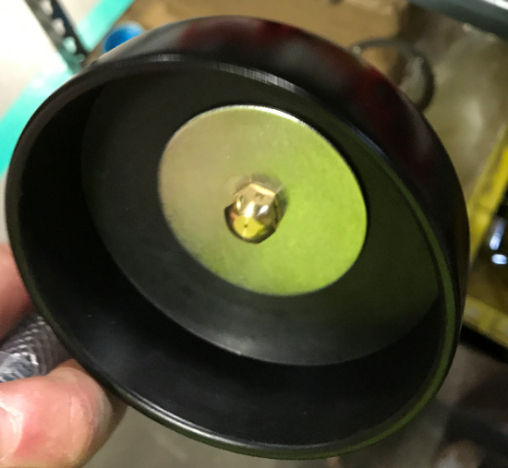
Nozzle

  - Thread the nozzle into the other port on the 90° fitting. Do not overtighten the nozzle as you will crush the filter inside of the 90° fitting. A snug fit will work.
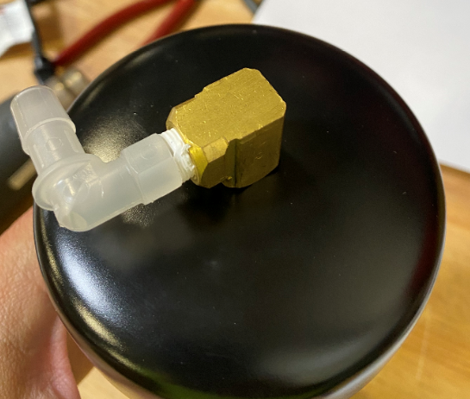
  - Install the top cap onto the chem tube.
  - Cut a 2” piece of 3/8” hose (E28620) and press it onto the barbed fitting on top of the chem tube canister. Place 2 pinch clamps (E28773) onto the tubing. Do not yet pinch them. Next, press a barbed elbow (E28536) into the other end of the tube.
  - Cut a 10 1/2” long piece of 3/8” hose (E28620) and press it onto the barbed elbow. Place 2 more pinch clamps (E28773) onto the tube. Do not yet pinch them. Next, press the pass through end of a T-fitting (E29315) onto the tube.
  - Cut a 2.5” piece of 3/8” hose (E28620) and press a restrictor plug (E29345) into it. Place 2 pinch clamps (E28773) onto the hose. Do not yet tighten them. Install the hose between the T-Fitting on the bottom of the chem tube and the T-fitting that was just installed.

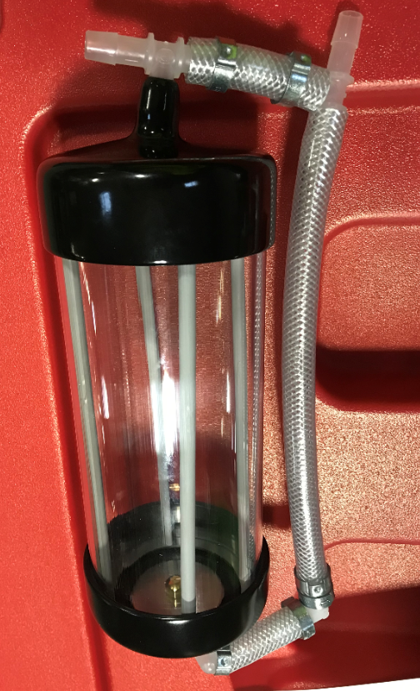
T Fitting
10.5” Hose
Elbow
2.5” Hose
2” Hose
Restrictor Plug

  - Adjust the canister assembly with the hoses so that they sit properly and are not flexing the wrong way. Once everything is good, pinch all of the clamps to secure them.

- References (optional section as needed)

- Training Guide

Functional Training Groups Requiring Training
Equipment Assembly Group

- SOP Change Control

Date of Change | Reason for Change
Rev 01 | This is the first version of the S.O.P. hence there are no revisions to this document.
Rev 02 - 8/13/2021 | Added QC check notes
Rev 03 - 10/26/2021 | Moved the puck cage installation to the main machine build.
Rev 04 - 3/31/2025 | Combined the MSAS and G20 instructions

Approvals

Submitter/Author Approval:__________________________________ Date:______________________

Management Approval:______________________________________ Date:______________________

QAU Approval:_____________________________________________ Date:______________________

